CSA05-DATABASE MANAGEMENT SYSTEMS
LAB OBSERVATION
EXPERIMENT:08
AIM:
To perform subquery and correlated query on the given relations.
QUESTION:
- Which of the student’s score is greater than the average score?
SQL QUERIES:
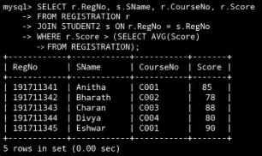
2. Which of the students’ have written more than one assessment test?
SQL QUERIES:
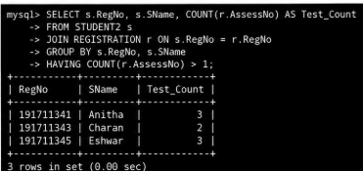
3. Which faculty has joined recently and when?
SQL QUERIES:
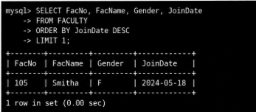
4. List the course and score of assessments that have the value more than the average score each Course
SQL QUERIES:
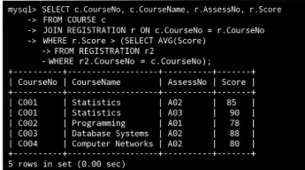
RESULT:
The records from the tables are displayed using Sub-Query and Correlated Sub-Query.

